Corporate Social Responsibility EVENING
Sofia, November 17, 2010

COMPANIes CULTURAL SUPPORT
List of Leaders on
Occasion of Austrian National Holiday

Bürgermeister der Stadt Russe
Herr Bozhidar Jotov
http://www.ruse-bg.eu/

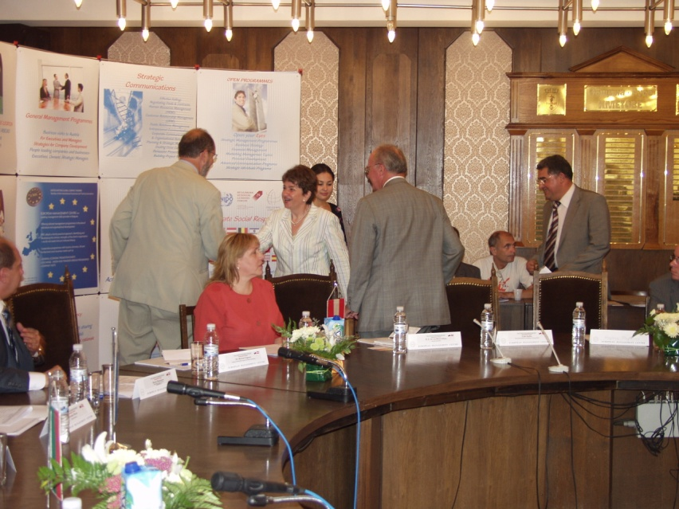

Dr. Andreas Schoberwalter PhD
Executive Director & Member of the
Management Board, Bulgarski Imoti Plc.
Vienna Insurance Group
andreas.schoberwalter@bulgarskiimoti.bg
www.bulgarskiimoti.bg

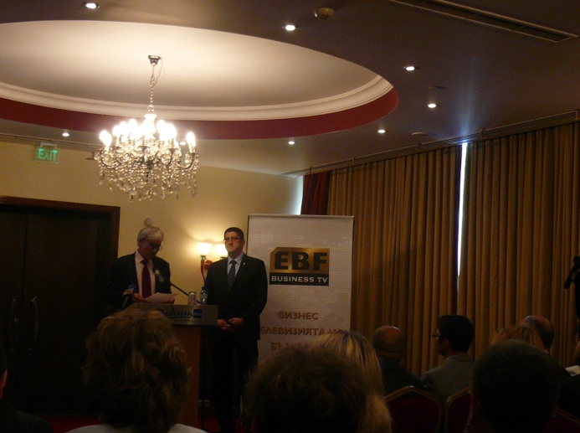

Herr. Petar Manovski
Head Office BULSTRAD
Director Marketing and CRM Division
Address: Sofia 1000, 5 "Pozitano" Sq.
Tel: 359 2/985 62 58
petar_manovski@bulstrad.bg
www.bulgarskiimoti.bg

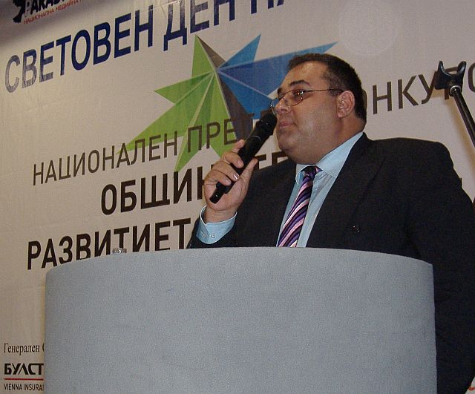
Dr.Darinka Despotova
Executive Directors
DUROPACK
A member of the CONSTANTIA Packaging Group
Pazardzhik 4400, Bulgaria
Despotova.Darinka@duropack.bg
www.duropack.bg

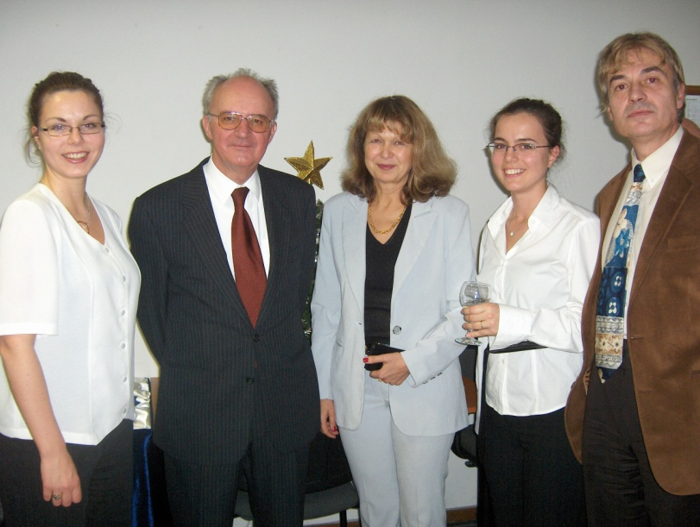

Ms. Boryana Manolova
Executive Director
Siemens Bulgaria
www.siemens.com

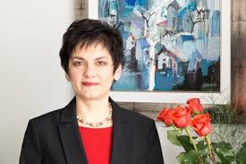

http://www.capital.bg/biznes/kompanii/2012/04/06/1803252_vienska_dostavka/

Mr. Pavel Petrov
President
Management Business Machine - M&BM Ltd.
http://www.mbm-bg.com

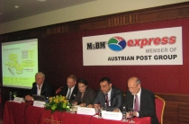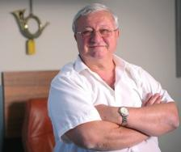

"МиБМ Експрес" е основана през 2005 г. като звено за куриерска дейност на групата M&BM. Дялове в "МиБМ Експрес" има доставчикът на машини и консумативи с марката XEROX "Мениджмънт бизнес машин" и Силвия Накова. Основите на групата през 1991 г. полага собственикът и управител Павел Петров. През 1986 г. той е сред основателите на държавното предприятие "Информационно обслужване", където работи до 1991 г. Според системата "Дакси" Петров е член на сдружението "Българо-австрийски мениджмънт форум".

Mag. Dimiter Tsotsorkov
Assarel-Medet JSC Mining and Processing Complex
Director Corporate Development
http://www.asarel.com/

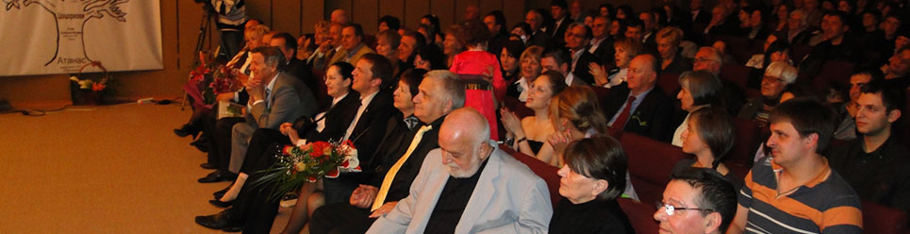

Mr. Stanislav Razpopov
Dunapack-Rodina JSC
Managing Director
Part of Austrian Concern
for paper and packaging production
PRINZHORN GROUP.
Contact Person;Ms.Maria Ivanova, Marketing&PR
http://www.dunapack.bg/

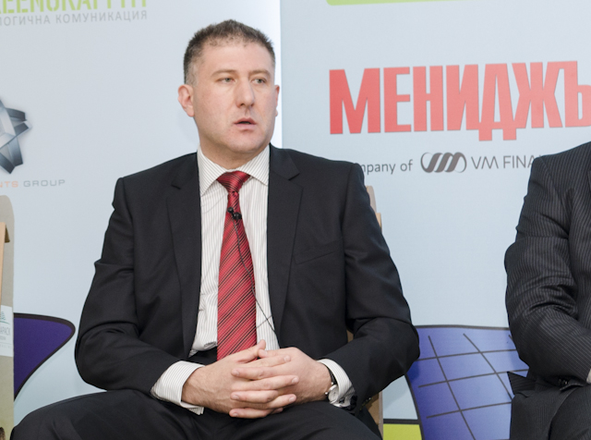

Mr.Dimitar Spassov
GLV Kaufland Bulgarien
Geschäftsführer
http://www.kaufland.bg

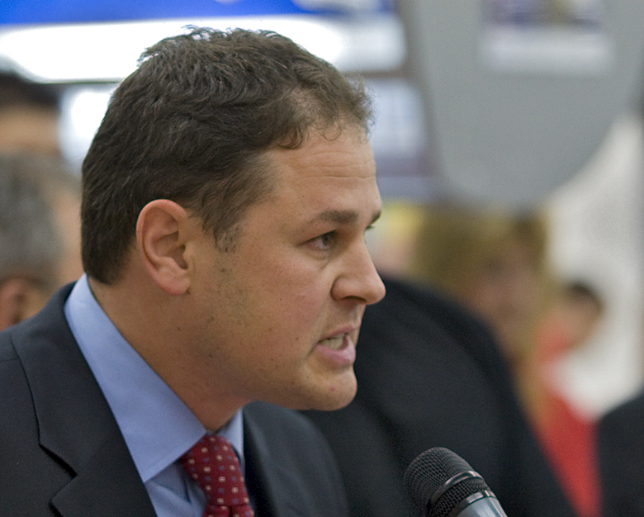

Ms.Pepa Nankova-Dimitrova and
Geschaeftsfuehrerin
PNB Ltd.
http://pnb.bg

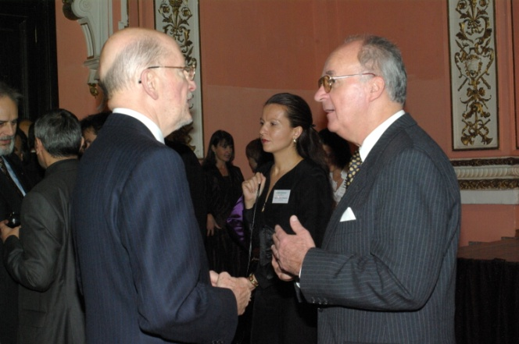

Dr. Milko Michov
Managing Director
J.W. Cappelen Bulgaria EOOD
http://www.jwc-group.com/
Ms.Iva Koleva
Assistant to MD

Mr.Kiril Vatev
Geschäftsführer
Tandem-V Ltd
http://www.tandem.bg

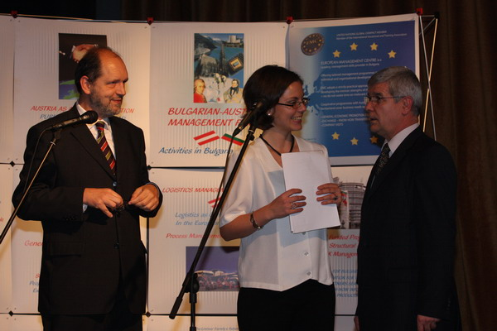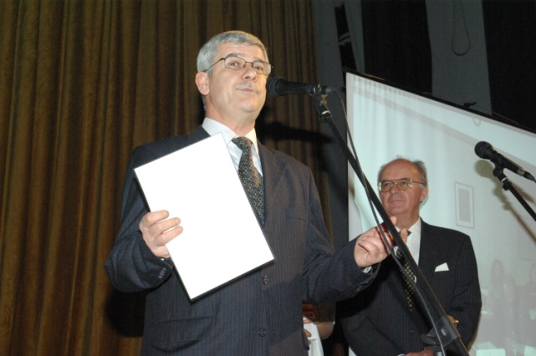

Mag.Ivan Todorov
President
TODOROFF Wine Cellar
http://www.todoroff-wines.com/

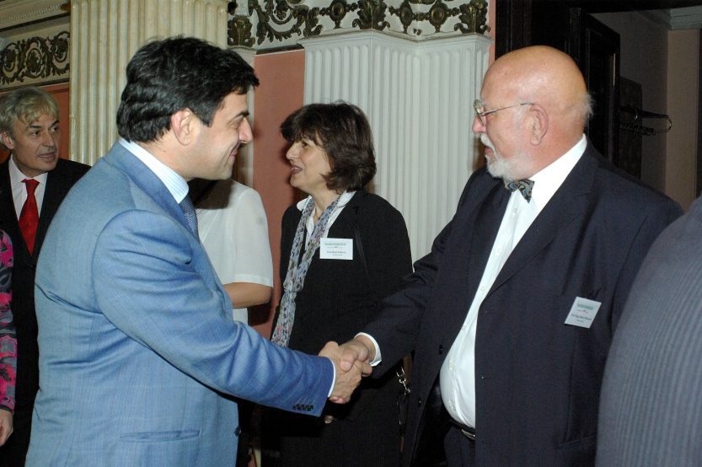

Dr.Pencho Ivankin
President
Balkan Consult Commerce, Sofia
www.bkkbg.com

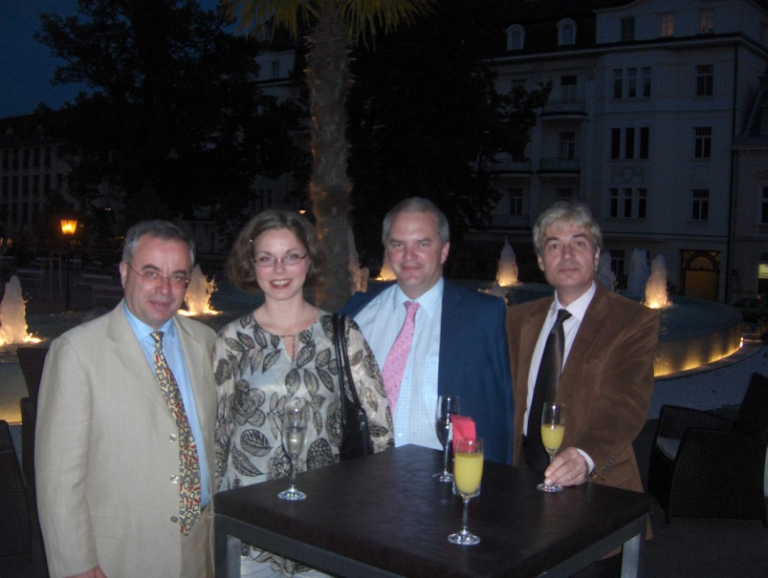

Dr.Eng Lachezar Tsotsorkov
Executive Director
Assarel-Medet JSC Mining and Processing Complex
http://www.asarel.com/

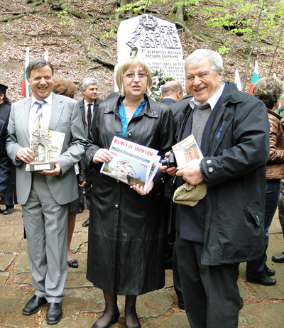

Prof.Dr. Eng.Krassimir Enimanev
Russe Technical University
Varna Free University
http://www.uni-ruse.bg/

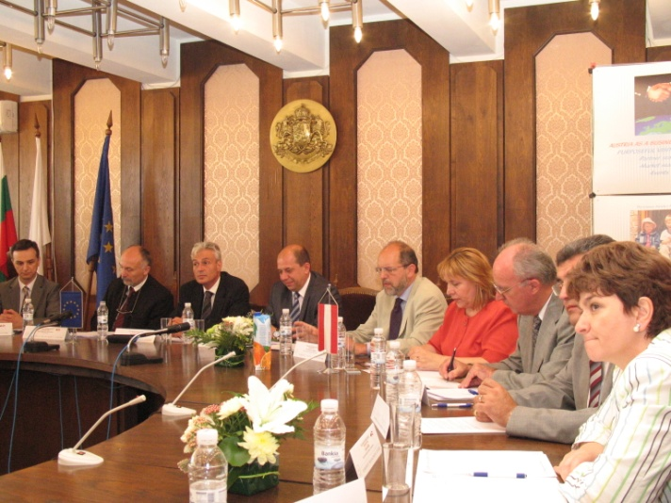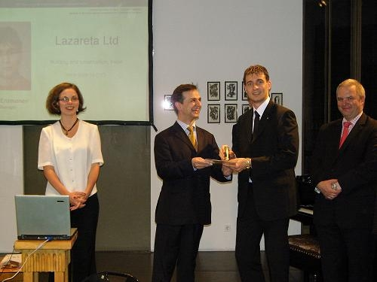

Herr.Plamen Stoyanov
Geschäftsführer
SOS Children's Villages Bulgaria
http://www.sosbg.org

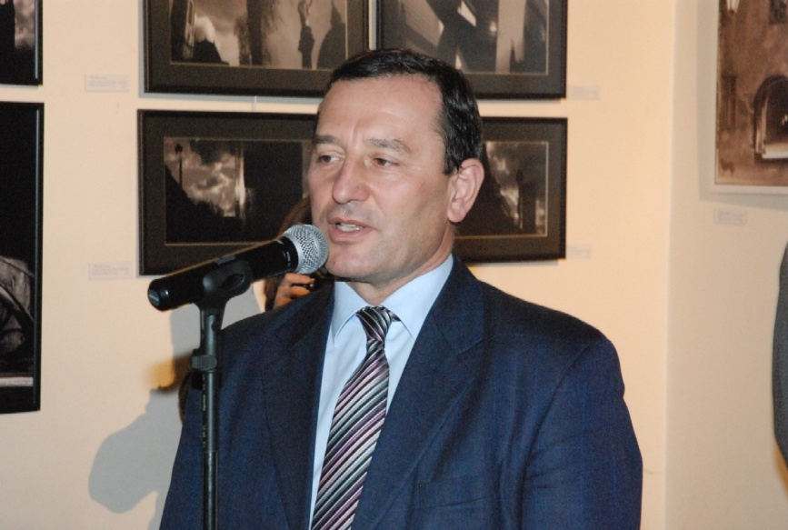

Ms. Natalia Bondarenko
General Manager
ARCHMEDIA

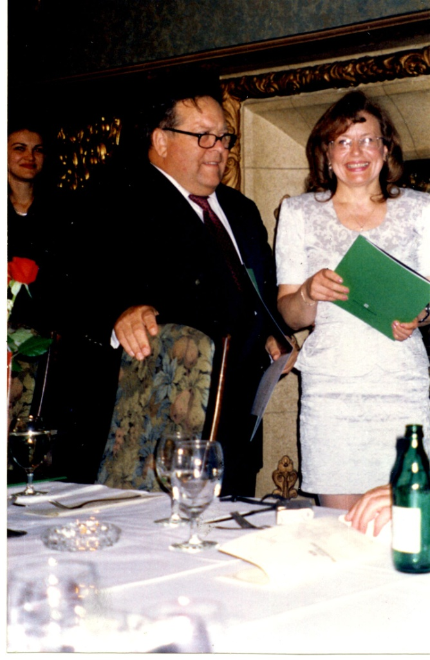

Mr.Robert Radoslavov
RUBISHIPS LTD - ROUSSE
SHIPOWNERS, BROKERS & AGENTS
Executive Director
http://www.rubiships.com

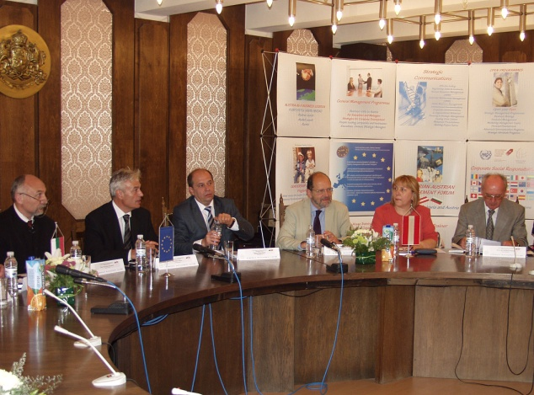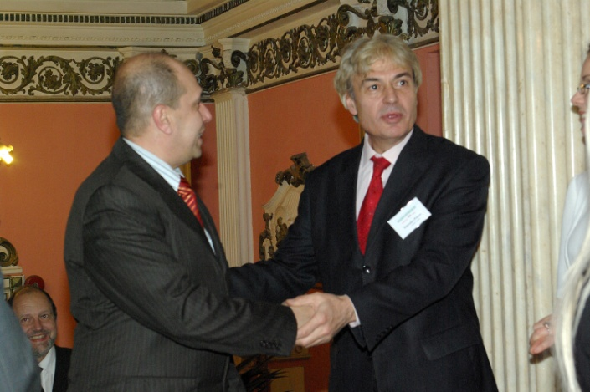

Mr. Ivan Kukov
Executive Director
Filkab JSCo.
www.filkab.com
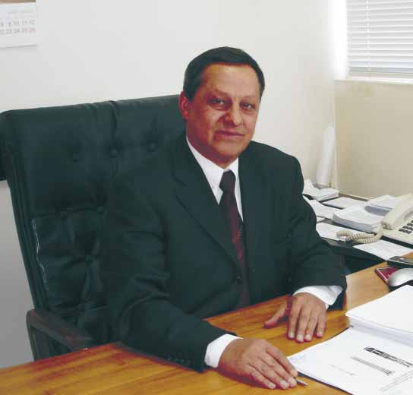

Mr. Orlin Dimitrov
E.ON Bulgaria EAD
Geschäftsführer
E.ON Sofia Office
http://www.eon-bulgaria.com

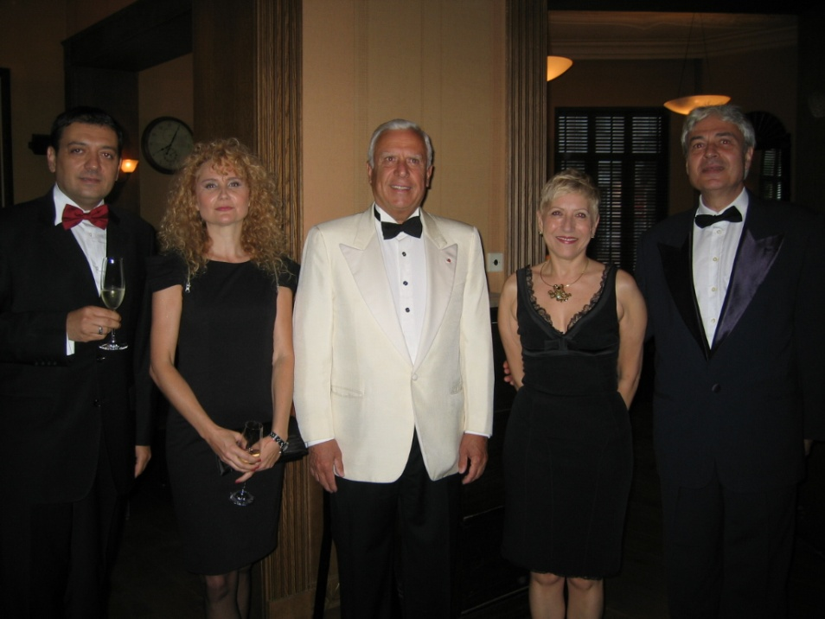

Eng. Mr. Zhelju Dobrev
Geschäftsführer
STROY CONSULT LTD.
http://www.stroy-consult.com/

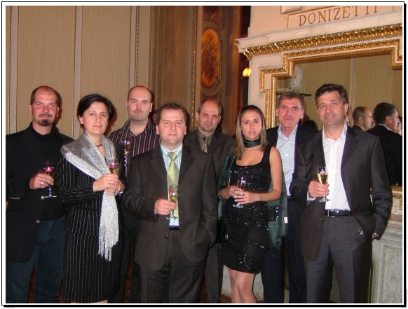

Mr.Peter Peryanov
President
Nikrom Mebel JSC
www.nikrommebel.bg
www.unised.bg

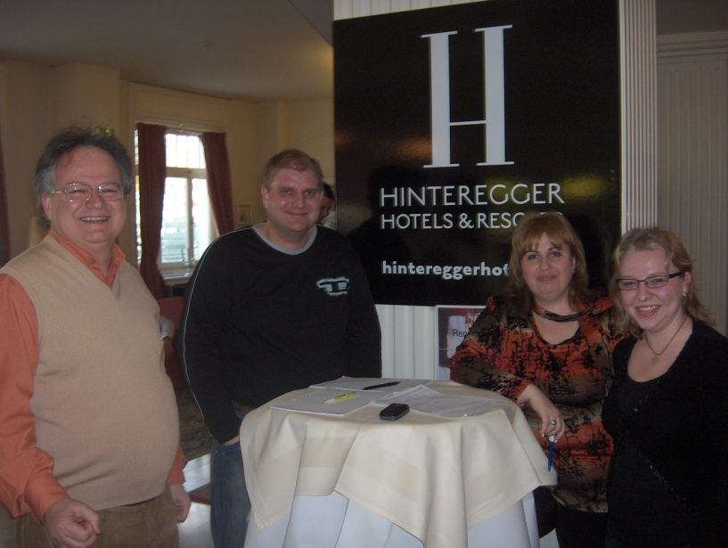

Mag. Viktor Milchev
Ginzler Stahl- u. Anlagenbau GmbH
Representative, Bulgarien
http://www.ginzler.at

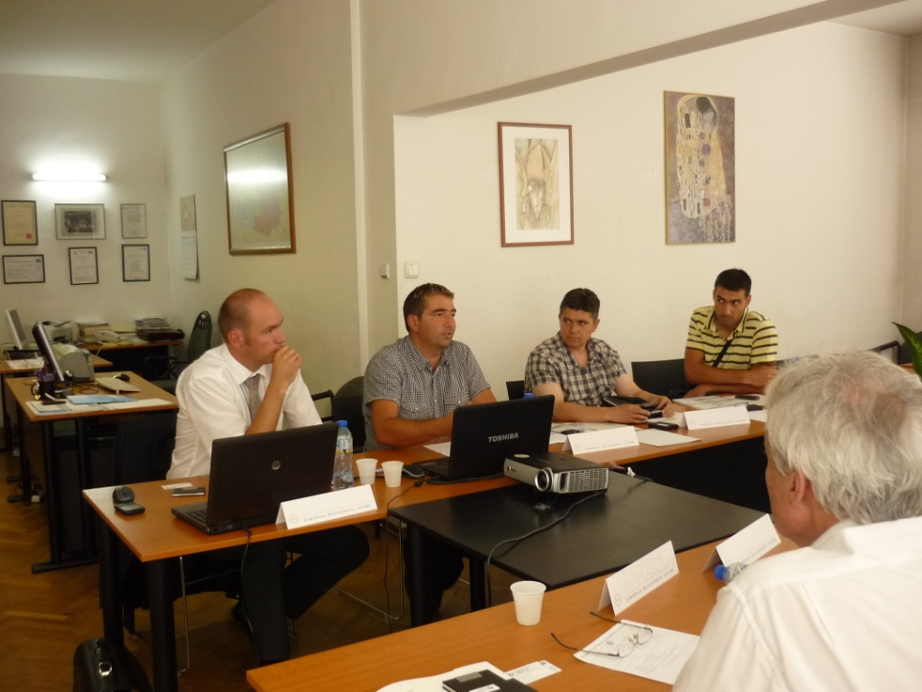

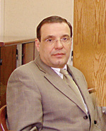
Eng. Lyudmil Lalov - Chairman of the Boards of Directors
Assarel-Medet JSC
http://www.asarel.com/

Mag. Diana Petrova
Executive Director
Salon Efekt BEAUTY SALON Ltd.
http://www.saloneffect.com

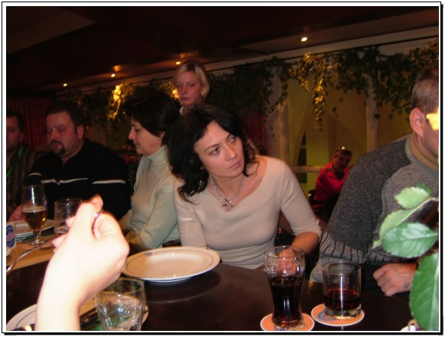

Mr.Alexander Rangelov, M.Sc.
Managing Director
International Power Supply Ltd
www.ips-group.net

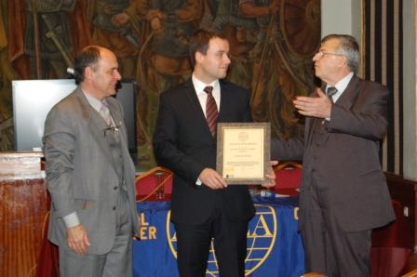

Mag.Zlatko Zlatanov
Geschäftsführer
SPA & Wellness Hotel RICH
http://www.hotel-rich.com/velingrad/

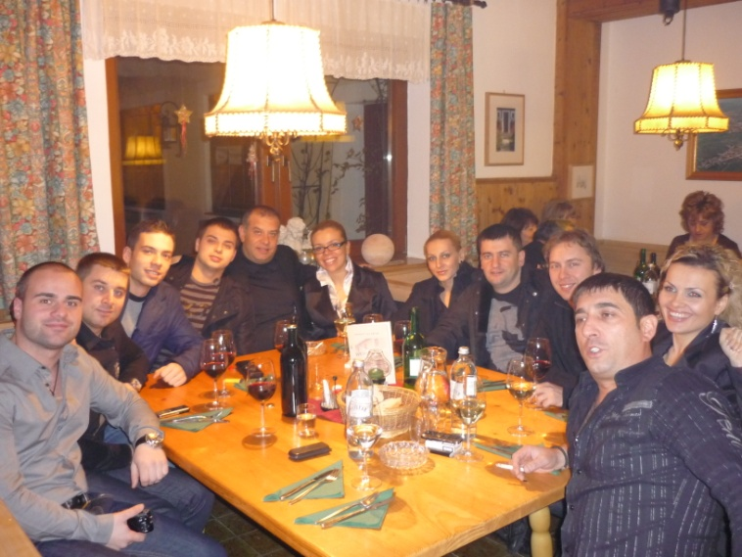

Mr. Boyan Dotchev
Alpina LTD
Director Administration and Logistics
www.alpina.bg

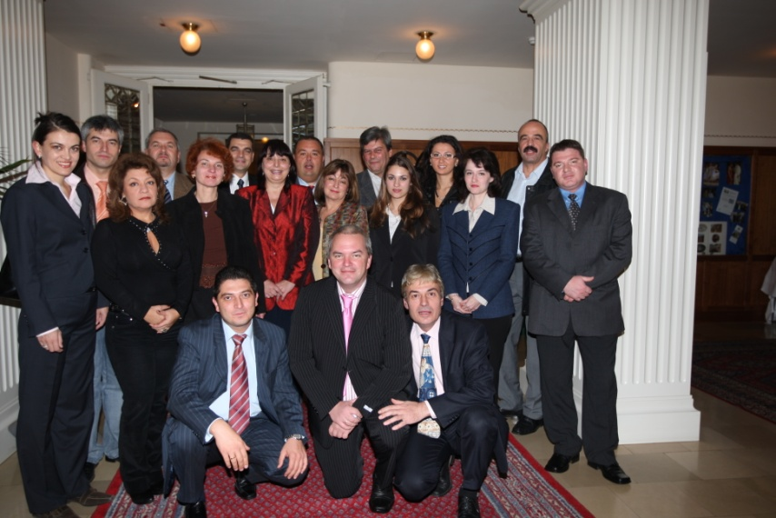

Mr.Ivan Akov
Geschäftsführer
SOLID 55 Ltd
http://www.solid55.com

